## Introduction

Pokémon which means “Pocket Monster”, they are a fictional cartoon character which is aired in the television in year 1999. On its pioneering years, Nintendo released its first game Pokémon Yellow, Red and Blue. This Role Playing Game (RPG) start with the main character “Ash” and you must defeat the gym leaders and the elite 4 of the tournaments. Before defeating them you must at least collect all the Pokémon or just the Pokémon you encountered along the way. In order to view the Pokémon you captured, “Professor Oak” shall give you the gadget “Pokédex”.

## Current System

The Pokédex is a handheld electronic encyclopedia device; one which is capable of recording and retaining information of the various Pokémon of the world. In order to accomplish Professor Oak's goal of a complete Pokémon database, the Pokédex is designed to find and record data on each Pokémon the Trainer meets. Pokémon are added to the Pokédex simply by encountering them in battle or (in certain instance) by seeing a picture of the Pokémon. However, detailed entries are not recorded until the player catches the Pokémon, receives it as a prize/gift or acquires it in a trade.

## Proposed System

The Pokédex is just a fictional electronic encyclopedia device for Pokémon. So now I’m proposing a game called “WTP (Who’s That PokéMon?)” from Pokédex that will enumerate what Pokémon is on the screen. The Pokémon is on a shadow form and if the user guesses what Pokémon it is, its true image will appear in the Pokédex screen. ­­

## Program Specification

Input Specification

|  |  |  |  |
| --- | --- | --- | --- |
| Name | Description | Type | Range |
| Pokname | Pokemon Name | String | A-Z |
| Pokcount | Count of letters left | Integer | - |
| Countpic | Pictures Count | Integer | - |
| Correct | Correct Score | Integer | - |
| Wrong | Wrong Score | Integer | - |
| Letter | Alphabetical Letters | String | A-Z |
| Lblcount | Label count | Integer | 1 |
| picb, picnext | Images | ImageIcon | - |
| Ee |  | Boolean | - |
| Cnt |  | Integer | - |

Screen Design

GAME SCREEN

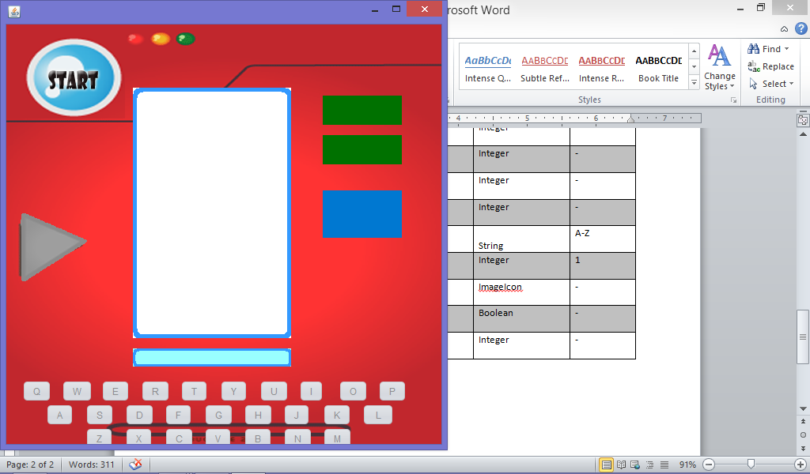

IN GAME SCREEN

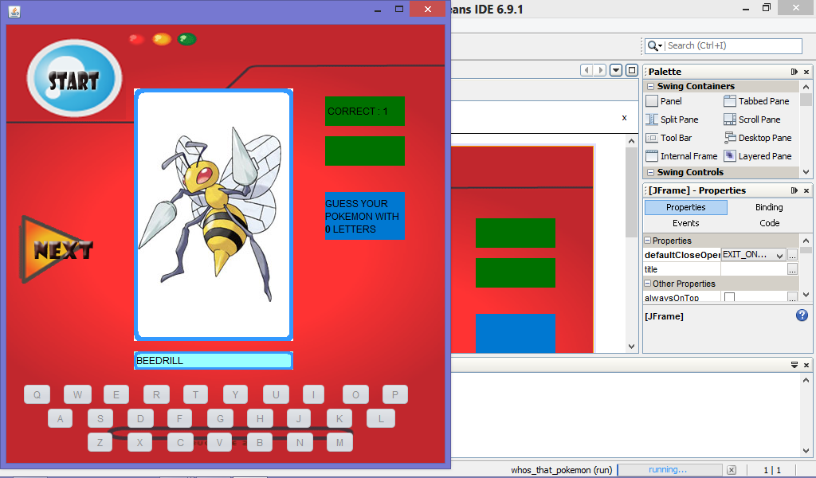

Program Design

***PSEUDOCODE***

*DO*

*PRESS START*

*WRONG is equals to zero*

*CORRECT is equals to zero*

*DISPLAY POKEMON PICTURE*

*PRESS ALPHABET BUTTONS*

*IF*

*CORRECT INPUT OF LETTERS THEN*

*+1 TO CORRECT*

*DISPLAY CORRECT 1*

*ELSE*

*+1 TO WRONG*

*DISPLAY WRONG 1*

*END IF*

*END DO*

# Program Listing

package whosthatpokemon;

import java.awt.Color;

import java.awt.event.*;

import java.util.Random;

import javax.swing.*;

import javax.swing.Timer;

public class menuForm extends javax.swing.JFrame {

/** Creates new form menuForm */

String pokname;

int pokcount;

int countpic=0;

int correct=0;

int wrong=0;

String letter;

int lblcount=1;

ImageIcon picb, picnext;

boolean ee;

int cnt;

public menuForm() {

initComponents();

}

private void initComponents() {

jButton23 = new javax.swing.JButton();

lbllettercount = new javax.swing.JLabel();

lblimage = new javax.swing.JLabel();

lblname = new javax.swing.JLabel();

jButton1 = new javax.swing.JButton();

jButton2 = new javax.swing.JButton();

jButton4 = new javax.swing.JButton();

jButton6 = new javax.swing.JButton();

jButton7 = new javax.swing.JButton();

jButton8 = new javax.swing.JButton();

jButton9 = new javax.swing.JButton();

jButton10 = new javax.swing.JButton();

jButton11 = new javax.swing.JButton();

jButton12 = new javax.swing.JButton();

jButton13 = new javax.swing.JButton();

jButton14 = new javax.swing.JButton();

jButton15 = new javax.swing.JButton();

jButton16 = new javax.swing.JButton();

jButton5 = new javax.swing.JButton();

jButton3 = new javax.swing.JButton();

jButton17 = new javax.swing.JButton();

jButton18 = new javax.swing.JButton();

jButton19 = new javax.swing.JButton();

jButton20 = new javax.swing.JButton();

jButton21 = new javax.swing.JButton();

jButton22 = new javax.swing.JButton();

jButton24 = new javax.swing.JButton();

jButton25 = new javax.swing.JButton();

jButton26 = new javax.swing.JButton();

jButton27 = new javax.swing.JButton();

lblcorrect = new javax.swing.JLabel();

lblwrong = new javax.swing.JLabel();

cmdstart = new javax.swing.JButton();

correctlabel = new javax.swing.JLabel();

wronglabel = new javax.swing.JLabel();

jLabel1 = new javax.swing.JLabel();

setDefaultCloseOperation(javax.swing.WindowConstants.EXIT_ON_CLOSE);

getContentPane().setLayout(new org.netbeans.lib.awtextra.AbsoluteLayout());

jButton23.setIcon(new javax.swing.ImageIcon(getClass().getResource("/whosthatpokemon/next.png"))); // NOI18N

jButton23.setContentAreaFilled(false);

jButton23.setEnabled(false);

jButton23.addMouseListener(new java.awt.event.MouseAdapter() {

public void mouseExited(java.awt.event.MouseEvent evt) {

jButton23MouseExited(evt);

}

public void mouseClicked(java.awt.event.MouseEvent evt) {

jButton23MouseClicked(evt);

}

public void mousePressed(java.awt.event.MouseEvent evt) {

jButton23MousePressed(evt);

}

});

jButton23.addMouseMotionListener(new java.awt.event.MouseMotionAdapter() {

public void mouseMoved(java.awt.event.MouseEvent evt) {

jButton23MouseMoved(evt);

}

});

jButton23.addActionListener(new java.awt.event.ActionListener() {

public void actionPerformed(java.awt.event.ActionEvent evt) {

jButton23ActionPerformed(evt);

}

});

getContentPane().add(jButton23, new org.netbeans.lib.awtextra.AbsoluteConstraints(-10, 230, 130, 100));

lbllettercount.setBackground(new java.awt.Color(0, 120, 209));

lbllettercount.setOpaque(true);

getContentPane().add(lbllettercount, new org.netbeans.lib.awtextra.AbsoluteConstraints(400, 210, 100, 60));

lblimage.setBackground(new java.awt.Color(255, 255, 255));

lblimage.setBorder(new javax.swing.border.LineBorder(new java.awt.Color(51, 153, 255), 5, true));

lblimage.setOpaque(true);

lblimage.setPreferredSize(new java.awt.Dimension(181, 234));

getContentPane().add(lblimage, new org.netbeans.lib.awtextra.AbsoluteConstraints(160, 80, 200, 317));

lblname.setBackground(new java.awt.Color(153, 255, 255));

lblname.setBorder(new javax.swing.border.LineBorder(new java.awt.Color(51, 153, 255), 3, true));

lblname.setOpaque(true);

getContentPane().add(lblname, new org.netbeans.lib.awtextra.AbsoluteConstraints(160, 410, 200, 23));

lblname.getAccessibleContext().setAccessibleName("lblname");

jButton1.setText("A");

jButton1.setEnabled(false);

jButton1.addActionListener(new java.awt.event.ActionListener() {

public void actionPerformed(java.awt.event.ActionEvent evt) {

jButton1ActionPerformed(evt);

}

});

getContentPane().add(jButton1, new org.netbeans.lib.awtextra.AbsoluteConstraints(50, 480, -1, -1));

jButton2.setText("B");

jButton2.setEnabled(false);

jButton2.addActionListener(new java.awt.event.ActionListener() {

public void actionPerformed(java.awt.event.ActionEvent evt) {

jButton2ActionPerformed(evt);

}

});

getContentPane().add(jButton2, new org.netbeans.lib.awtextra.AbsoluteConstraints(300, 510, -1, -1));

jButton4.setText("D");

jButton4.setEnabled(false);

jButton4.addActionListener(new java.awt.event.ActionListener() {

public void actionPerformed(java.awt.event.ActionEvent evt) {

jButton4ActionPerformed(evt);

}

});

getContentPane().add(jButton4, new org.netbeans.lib.awtextra.AbsoluteConstraints(150, 480, -1, -1));

jButton6.setText("C");

jButton6.setEnabled(false);

jButton6.addActionListener(new java.awt.event.ActionListener() {

public void actionPerformed(java.awt.event.ActionEvent evt) {

jButton6ActionPerformed(evt);

}

});

getContentPane().add(jButton6, new org.netbeans.lib.awtextra.AbsoluteConstraints(200, 510, -1, -1));

jButton7.setText("I");

jButton7.setEnabled(false);

jButton7.addActionListener(new java.awt.event.ActionListener() {

public void actionPerformed(java.awt.event.ActionEvent evt) {

jButton7ActionPerformed(evt);

}

});

getContentPane().add(jButton7, new org.netbeans.lib.awtextra.AbsoluteConstraints(370, 450, -1, -1));

jButton8.setText("F");

jButton8.setEnabled(false);

jButton8.addActionListener(new java.awt.event.ActionListener() {

public void actionPerformed(java.awt.event.ActionEvent evt) {

jButton8ActionPerformed(evt);

}

});

getContentPane().add(jButton8, new org.netbeans.lib.awtextra.AbsoluteConstraints(200, 480, -1, -1));

jButton9.setText("H");

jButton9.setEnabled(false);

jButton9.addActionListener(new java.awt.event.ActionListener() {

public void actionPerformed(java.awt.event.ActionEvent evt) {

jButton9ActionPerformed(evt);

}

});

getContentPane().add(jButton9, new org.netbeans.lib.awtextra.AbsoluteConstraints(300, 480, -1, -1));

jButton10.setText("E");

jButton10.setEnabled(false);

jButton10.addActionListener(new java.awt.event.ActionListener() {

public void actionPerformed(java.awt.event.ActionEvent evt) {

jButton10ActionPerformed(evt);

}

});

getContentPane().add(jButton10, new org.netbeans.lib.awtextra.AbsoluteConstraints(120, 450, -1, -1));

jButton11.setText("G");

jButton11.setEnabled(false);

jButton11.addActionListener(new java.awt.event.ActionListener() {

public void actionPerformed(java.awt.event.ActionEvent evt) {

jButton11ActionPerformed(evt);

}

});

getContentPane().add(jButton11, new org.netbeans.lib.awtextra.AbsoluteConstraints(250, 480, -1, -1));

jButton12.setText("N");

jButton12.setEnabled(false);

jButton12.addActionListener(new java.awt.event.ActionListener() {

public void actionPerformed(java.awt.event.ActionEvent evt) {

jButton12ActionPerformed(evt);

}

});

getContentPane().add(jButton12, new org.netbeans.lib.awtextra.AbsoluteConstraints(350, 510, -1, -1));

jButton13.setText("P");

jButton13.setEnabled(false);

jButton13.addActionListener(new java.awt.event.ActionListener() {

public void actionPerformed(java.awt.event.ActionEvent evt) {

jButton13ActionPerformed(evt);

}

});

getContentPane().add(jButton13, new org.netbeans.lib.awtextra.AbsoluteConstraints(470, 450, -1, -1));

jButton14.setText("O");

jButton14.setEnabled(false);

jButton14.addActionListener(new java.awt.event.ActionListener() {

public void actionPerformed(java.awt.event.ActionEvent evt) {

jButton14ActionPerformed(evt);

}

});

getContentPane().add(jButton14, new org.netbeans.lib.awtextra.AbsoluteConstraints(420, 450, -1, -1));

jButton15.setText("Q");

jButton15.setEnabled(false);

jButton15.addActionListener(new java.awt.event.ActionListener() {

public void actionPerformed(java.awt.event.ActionEvent evt) {

jButton15ActionPerformed(evt);

}

});

getContentPane().add(jButton15, new org.netbeans.lib.awtextra.AbsoluteConstraints(20, 450, -1, -1));

jButton16.setText("R");

jButton16.setEnabled(false);

jButton16.addActionListener(new java.awt.event.ActionListener() {

public void actionPerformed(java.awt.event.ActionEvent evt) {

jButton16ActionPerformed(evt);

}

});

getContentPane().add(jButton16, new org.netbeans.lib.awtextra.AbsoluteConstraints(170, 450, -1, -1));

jButton5.setText("M");

jButton5.setEnabled(false);

jButton5.addActionListener(new java.awt.event.ActionListener() {

public void actionPerformed(java.awt.event.ActionEvent evt) {

jButton5ActionPerformed(evt);

}

});

getContentPane().add(jButton5, new org.netbeans.lib.awtextra.AbsoluteConstraints(400, 510, -1, -1));

jButton3.setText("K");

jButton3.setEnabled(false);

jButton3.addActionListener(new java.awt.event.ActionListener() {

public void actionPerformed(java.awt.event.ActionEvent evt) {

jButton3ActionPerformed(evt);

}

});

getContentPane().add(jButton3, new org.netbeans.lib.awtextra.AbsoluteConstraints(400, 480, -1, -1));

jButton17.setText("J");

jButton17.setEnabled(false);

jButton17.addActionListener(new java.awt.event.ActionListener() {

public void actionPerformed(java.awt.event.ActionEvent evt) {

jButton17ActionPerformed(evt);

}

});

getContentPane().add(jButton17, new org.netbeans.lib.awtextra.AbsoluteConstraints(350, 480, -1, -1));

jButton18.setText("L");

jButton18.setEnabled(false);

jButton18.addActionListener(new java.awt.event.ActionListener() {

public void actionPerformed(java.awt.event.ActionEvent evt) {

jButton18ActionPerformed(evt);

}

});

getContentPane().add(jButton18, new org.netbeans.lib.awtextra.AbsoluteConstraints(450, 480, 40, -1));

jButton19.setText("W");

jButton19.setEnabled(false);

jButton19.addActionListener(new java.awt.event.ActionListener() {

public void actionPerformed(java.awt.event.ActionEvent evt) {

jButton19ActionPerformed(evt);

}

});

getContentPane().add(jButton19, new org.netbeans.lib.awtextra.AbsoluteConstraints(70, 450, -1, -1));

jButton20.setText("Y");

jButton20.setEnabled(false);

jButton20.addActionListener(new java.awt.event.ActionListener() {

public void actionPerformed(java.awt.event.ActionEvent evt) {

jButton20ActionPerformed(evt);

}

});

getContentPane().add(jButton20, new org.netbeans.lib.awtextra.AbsoluteConstraints(270, 450, -1, -1));

jButton21.setText("X");

jButton21.setEnabled(false);

jButton21.addActionListener(new java.awt.event.ActionListener() {

public void actionPerformed(java.awt.event.ActionEvent evt) {

jButton21ActionPerformed(evt);

}

});

getContentPane().add(jButton21, new org.netbeans.lib.awtextra.AbsoluteConstraints(150, 510, -1, -1));

jButton22.setText("Z");

jButton22.setEnabled(false);

jButton22.addActionListener(new java.awt.event.ActionListener() {

public void actionPerformed(java.awt.event.ActionEvent evt) {

jButton22ActionPerformed(evt);

}

});

getContentPane().add(jButton22, new org.netbeans.lib.awtextra.AbsoluteConstraints(100, 510, -1, -1));

jButton24.setText("V");

jButton24.setEnabled(false);

jButton24.addActionListener(new java.awt.event.ActionListener() {

public void actionPerformed(java.awt.event.ActionEvent evt) {

jButton24ActionPerformed(evt);

}

});

getContentPane().add(jButton24, new org.netbeans.lib.awtextra.AbsoluteConstraints(250, 510, -1, -1));

jButton25.setText("T");

jButton25.setEnabled(false);

jButton25.addActionListener(new java.awt.event.ActionListener() {

public void actionPerformed(java.awt.event.ActionEvent evt) {

jButton25ActionPerformed(evt);

}

});

getContentPane().add(jButton25, new org.netbeans.lib.awtextra.AbsoluteConstraints(220, 450, -1, -1));

jButton26.setText("S");

jButton26.setEnabled(false);

jButton26.addActionListener(new java.awt.event.ActionListener() {

public void actionPerformed(java.awt.event.ActionEvent evt) {

jButton26ActionPerformed(evt);

}

});

getContentPane().add(jButton26, new org.netbeans.lib.awtextra.AbsoluteConstraints(100, 480, -1, -1));

jButton27.setText("U");

jButton27.setEnabled(false);

jButton27.addActionListener(new java.awt.event.ActionListener() {

public void actionPerformed(java.awt.event.ActionEvent evt) {

jButton27ActionPerformed(evt);

}

});

getContentPane().add(jButton27, new org.netbeans.lib.awtextra.AbsoluteConstraints(320, 450, -1, -1));

getContentPane().add(lblcorrect, new org.netbeans.lib.awtextra.AbsoluteConstraints(233, 305, -1, -1));

getContentPane().add(lblwrong, new org.netbeans.lib.awtextra.AbsoluteConstraints(233, 311, -1, -1));

cmdstart.setIcon(new javax.swing.ImageIcon(getClass().getResource("/whosthatpokemon/start.png"))); // NOI18N

cmdstart.setContentAreaFilled(false);

cmdstart.addMouseListener(new java.awt.event.MouseAdapter() {

public void mouseExited(java.awt.event.MouseEvent evt) {

cmdstartMouseExited(evt);

}

public void mousePressed(java.awt.event.MouseEvent evt) {

cmdstartMousePressed(evt);

}

});

cmdstart.addMouseMotionListener(new java.awt.event.MouseMotionAdapter() {

public void mouseMoved(java.awt.event.MouseEvent evt) {

cmdstartMouseMoved(evt);

}

});

cmdstart.addActionListener(new java.awt.event.ActionListener() {

public void actionPerformed(java.awt.event.ActionEvent evt) {

cmdstartActionPerformed(evt);

}

});

getContentPane().add(cmdstart, new org.netbeans.lib.awtextra.AbsoluteConstraints(0, 10, 170, 110));

correctlabel.setBackground(new java.awt.Color(0, 113, 0));

correctlabel.setOpaque(true);

getContentPane().add(correctlabel, new org.netbeans.lib.awtextra.AbsoluteConstraints(400, 90, 100, 37));

wronglabel.setBackground(new java.awt.Color(0, 113, 0));

wronglabel.setOpaque(true);

getContentPane().add(wronglabel, new org.netbeans.lib.awtextra.AbsoluteConstraints(400, 140, 100, 37));

jLabel1.setIcon(new javax.swing.ImageIcon(getClass().getResource("/whosthatpokemon/pokeback.png"))); // NOI18N

getContentPane().add(jLabel1, new org.netbeans.lib.awtextra.AbsoluteConstraints(0, 0, 550, 550));

pack();

}// </editor-fold>

private void jButton1ActionPerformed(java.awt.event.ActionEvent evt) {

letter="A";

callletter();

}

private void jButton2ActionPerformed(java.awt.event.ActionEvent evt) {

letter="B";

callletter();

}

private void jButton6ActionPerformed(java.awt.event.ActionEvent evt) {

letter="C";

callletter();

}

private void jButton4ActionPerformed(java.awt.event.ActionEvent evt) {

letter="D";

callletter();

}

private void jButton10ActionPerformed(java.awt.event.ActionEvent evt) {

letter="E";

callletter();

}

private void jButton8ActionPerformed(java.awt.event.ActionEvent evt) {

letter="F";

callletter();

}

private void jButton11ActionPerformed(java.awt.event.ActionEvent evt) {

letter="G";

callletter();

}

private void jButton9ActionPerformed(java.awt.event.ActionEvent evt) {

letter="H";

callletter();

}

private void jButton7ActionPerformed(java.awt.event.ActionEvent evt) {

letter="I";

callletter();

}

private void jButton17ActionPerformed(java.awt.event.ActionEvent evt) {

letter="J";

callletter();

}

private void jButton3ActionPerformed(java.awt.event.ActionEvent evt) {

letter="K";

callletter();

}

private void jButton18ActionPerformed(java.awt.event.ActionEvent evt) {

letter="L";

callletter();

}

private void jButton5ActionPerformed(java.awt.event.ActionEvent evt) {

letter="M";

callletter();

}

private void jButton12ActionPerformed(java.awt.event.ActionEvent evt) {

letter="N";

callletter();

}

private void jButton14ActionPerformed(java.awt.event.ActionEvent evt) {

letter="O";

callletter();

}

private void jButton13ActionPerformed(java.awt.event.ActionEvent evt) {

letter="P";

callletter();

}

private void jButton15ActionPerformed(java.awt.event.ActionEvent evt) {

letter="Q";

callletter();

}

private void jButton16ActionPerformed(java.awt.event.ActionEvent evt) {

letter="R";

callletter();

}

private void jButton26ActionPerformed(java.awt.event.ActionEvent evt) {

letter="S";

callletter();

}

private void jButton25ActionPerformed(java.awt.event.ActionEvent evt) {

letter="T";

callletter();

}

private void jButton27ActionPerformed(java.awt.event.ActionEvent evt) {

letter="U";

callletter();

}

private void jButton24ActionPerformed(java.awt.event.ActionEvent evt) {

letter="V";

callletter();

}

private void jButton19ActionPerformed(java.awt.event.ActionEvent evt) {

letter="W";

callletter();

}

private void jButton21ActionPerformed(java.awt.event.ActionEvent evt) {

letter="X";

callletter();

}

private void jButton20ActionPerformed(java.awt.event.ActionEvent evt) {

letter="Y";

callletter();

}

private void jButton22ActionPerformed(java.awt.event.ActionEvent evt) {

letter="Z";

callletter();

}

private void cmdstartActionPerformed(java.awt.event.ActionEvent evt) {

wrong=0;

correct=0;

if (wronglabel.getText() != "" || correctlabel.getText() == ""){

wronglabel.setText(null);

correctlabel.setText(null);

}

ee=true;

lblname.setText("");

callbuttonsenable();

picnext = new ImageIcon("images\\buttons\\next.png");

jButton23.setIcon(picnext);

showpic();

}

private void cmdstartMouseMoved(java.awt.event.MouseEvent evt) {

picnext = new ImageIcon("images\\buttons\\startmove.png");

cmdstart.setIcon(picnext);

}

private void cmdstartMouseExited(java.awt.event.MouseEvent evt) {

picnext = new ImageIcon("images\\buttons\\start.png");

cmdstart.setIcon(picnext);

}

private void cmdstartMousePressed(java.awt.event.MouseEvent evt) {

picnext = new ImageIcon("images\\buttons\\startpress.png");

cmdstart.setIcon(picnext);

}

private void jButton23MouseExited(java.awt.event.MouseEvent evt) {

if(ee) {

picnext = new ImageIcon("images\\buttons\\next.png");

jButton23.setIcon(picnext);

}

}

private void jButton23MousePressed(java.awt.event.MouseEvent evt) {

if(ee) {

picnext = new ImageIcon("images\\buttons\\nextpress.png");

jButton23.setIcon(picnext);

}

}

private void jButton23MouseMoved(java.awt.event.MouseEvent evt) {

if(ee) {

picnext = new ImageIcon("images\\buttons\\nextmove.png");

jButton23.setIcon(picnext);

}

}

private void jButton23ActionPerformed(java.awt.event.ActionEvent evt) {

countpic = countpic +1;

String pokename=lblname.getText().toLowerCase();

if (lblname.getText() == ""){

wrong = wrong + 1;

wronglabel.setText("WRONG : " + Integer.toString(wrong));

}

showpic();

callbuttonsenable();

}

private void jButton23MouseClicked(java.awt.event.MouseEvent evt) {

// TODO add your handling code here:

}

/**

* @param args the command line arguments

*/

public static void main(String args[]) {

/* Set the Nimbus look and feel */

//<editor-fold defaultstate="collapsed" desc=" Look and feel setting code (optional) ">

/* If Nimbus (introduced in Java SE 6) is not available, stay with the default look and feel.

* For details see http://download.oracle.com/javase/tutorial/uiswing/lookandfeel/plaf.html

*/

try {

for (javax.swing.UIManager.LookAndFeelInfo info : javax.swing.UIManager.getInstalledLookAndFeels()) {

if ("Nimbus".equals(info.getName())) {

javax.swing.UIManager.setLookAndFeel(info.getClassName());

break;

}

}

} catch (ClassNotFoundException ex) {

java.util.logging.Logger.getLogger(menuForm.class.getName()).log(java.util.logging.Level.SEVERE, null, ex);

} catch (InstantiationException ex) {

java.util.logging.Logger.getLogger(menuForm.class.getName()).log(java.util.logging.Level.SEVERE, null, ex);

} catch (IllegalAccessException ex) {

java.util.logging.Logger.getLogger(menuForm.class.getName()).log(java.util.logging.Level.SEVERE, null, ex);

} catch (javax.swing.UnsupportedLookAndFeelException ex) {

java.util.logging.Logger.getLogger(menuForm.class.getName()).log(java.util.logging.Level.SEVERE, null, ex);

}

//</editor-fold>

/* Create and display the form */

java.awt.EventQueue.invokeLater(new Runnable() {

public void run() {

new menuForm().setVisible(true);

}

});

}

// Variables declaration - do not modify

private javax.swing.JButton cmdstart;

private javax.swing.JLabel correctlabel;

private javax.swing.JButton jButton1;

private javax.swing.JButton jButton10;

private javax.swing.JButton jButton11;

private javax.swing.JButton jButton12;

private javax.swing.JButton jButton13;

private javax.swing.JButton jButton14;

private javax.swing.JButton jButton15;

private javax.swing.JButton jButton16;

private javax.swing.JButton jButton17;

private javax.swing.JButton jButton18;

private javax.swing.JButton jButton19;

private javax.swing.JButton jButton2;

private javax.swing.JButton jButton20;

private javax.swing.JButton jButton21;

private javax.swing.JButton jButton22;

private javax.swing.JButton jButton23;

private javax.swing.JButton jButton24;

private javax.swing.JButton jButton25;

private javax.swing.JButton jButton26;

private javax.swing.JButton jButton27;

private javax.swing.JButton jButton3;

private javax.swing.JButton jButton4;

private javax.swing.JButton jButton5;

private javax.swing.JButton jButton6;

private javax.swing.JButton jButton7;

private javax.swing.JButton jButton8;

private javax.swing.JButton jButton9;

private javax.swing.JLabel jLabel1;

private javax.swing.JLabel lblcorrect;

private javax.swing.JLabel lblimage;

private javax.swing.JLabel lbllettercount;

private javax.swing.JLabel lblname;

private javax.swing.JLabel lblwrong;

private javax.swing.JLabel wronglabel;

// End of variables declaration

private void callletter() {

if(lblcount < pokcount){

String name=lblname.getText() + letter;

lblname.setText(name);

}

lblcount=lblname.getText().length();

lbllettercount.setText("<html>GUESS YOUR <br>POKEMON WITH <b>" + Integer.toString(pokcount-lblcount) + "</b> LETTERS</html>");

if(lblcount == pokcount){

String pokename=lblname.getText().toLowerCase();

if(pokename.equals(pokname) ){

correct = correct + 1;

correctlabel.setText(" CORRECT : "+Integer.toString(correct));

picb = new ImageIcon("images\\"+ pokname +".jpg");

lblimage.setIcon(picb);

}

else{

wrong = wrong + 1;

wronglabel.setText(" WRONG : "+Integer.toString(wrong));

}

}

if(lblcount >= pokcount){

calldisablebuttons();

}

}

private void calldisablebuttons() {

jButton1.setEnabled(false);

jButton2.setEnabled(false);

jButton6.setEnabled(false);

jButton4.setEnabled(false);

jButton10.setEnabled(false);

jButton8.setEnabled(false);

jButton11.setEnabled(false);

jButton9.setEnabled(false);

jButton7.setEnabled(false);

jButton17.setEnabled(false);

jButton3.setEnabled(false);

jButton18.setEnabled(false);

jButton5.setEnabled(false);

jButton12.setEnabled(false);

jButton14.setEnabled(false);

jButton13.setEnabled(false);

jButton15.setEnabled(false);

jButton16.setEnabled(false);

jButton25.setEnabled(false);

jButton26.setEnabled(false);

jButton27.setEnabled(false);

jButton24.setEnabled(false);

jButton19.setEnabled(false);

jButton21.setEnabled(false);

jButton20.setEnabled(false);

jButton22.setEnabled(false);

}

private void callbuttonsenable() {

jButton1.setEnabled(true);

jButton2.setEnabled(true);

jButton6.setEnabled(true);

jButton4.setEnabled(true);

jButton10.setEnabled(true);

jButton8.setEnabled(true);

jButton11.setEnabled(true);

jButton9.setEnabled(true);

jButton7.setEnabled(true);

jButton17.setEnabled(true);

jButton3.setEnabled(true);

jButton18.setEnabled(true);

jButton5.setEnabled(true);

jButton12.setEnabled(true);

jButton14.setEnabled(true);

jButton13.setEnabled(true);

jButton15.setEnabled(true);

jButton16.setEnabled(true);

jButton25.setEnabled(true);

jButton26.setEnabled(true);

jButton27.setEnabled(true);

jButton24.setEnabled(true);

jButton19.setEnabled(true);

jButton21.setEnabled(true);

jButton20.setEnabled(true);

jButton22.setEnabled(true);

jButton23.setEnabled(true);

}

private void showpic() {

Random random = new Random();

int randomInteger = (int) ((Math.random() * 35)+1);

countpic=randomInteger;

lblname.setText("");

if (countpic==1){

picb = new ImageIcon("images\\shadows\\beedrill.png");

pokcount = 8;

pokname = "beedrill";

}

else if (countpic==2) {

picb = new ImageIcon("images\\shadows\\blastoise.png");

pokcount = 9;

pokname = "blastoise";

}

else if (countpic==3){

picb = new ImageIcon("images\\shadows\\bulbasaur.png");

pokcount = 9;

pokname = "bulbasaur";

}

else if (countpic==4) {

picb = new ImageIcon("images\\shadows\\butterfree.png");

pokcount = 10;

pokname = "butterfree";

}

else if (countpic==5) {

picb = new ImageIcon ("images\\shadows\\caterpie.png");

pokcount = 8;

pokname = "caterpie";

}

else if (countpic==6) {

picb = new ImageIcon ("images\\shadows\\charizard.png");

pokcount = 9;

pokname = "charizard";

}

else if (countpic==7) {

picb = new ImageIcon ("images\\shadows\\charmander.png");

pokcount = 10;

pokname = "charmander";

}

else if (countpic==8) {

picb = new ImageIcon ("images\\shadows\\charmeleon.png");

pokcount = 10;

pokname = "charmeleon";

}

else if (countpic==9) {

picb = new ImageIcon ("images\\shadows\\clefairy.png");

pokcount = 8;

pokname = "clefairy";

}

else if (countpic==10) {

picb = new ImageIcon ("images\\shadows\\clefable.png");

pokcount = 8;

pokname = "clefable";

}

else if (countpic==11) {

picb = new ImageIcon ("images\\shadows\\geodude.png");

pokcount = 7;

pokname = "geodude";

}

else if (countpic==12) {

picb = new ImageIcon ("images\\shadows\\graveler.png");

pokcount = 8;

pokname = "graveler";

}

else if (countpic==13) {

picb = new ImageIcon ("images\\shadows\\ivysaur.png");

pokcount = 7;

pokname = "ivysaur";

}

else if (countpic==14) {

picb = new ImageIcon ("images\\shadows\\jigglypuff.png");

pokcount = 10;

pokname = "jigglypuff";

}

else if (countpic==15) {

picb = new ImageIcon ("images\\shadows\\kakuna.png");

pokcount = 6;

pokname = "kakuna";

}

else if (countpic==16) {

picb = new ImageIcon ("images\\shadows\\meowth.png");

pokcount = 6;

pokname = "meowth";

}

else if (countpic==17) {

picb = new ImageIcon ("images\\shadows\\metapod.png");

pokcount = 7;

pokname = "metapod";

}

else if (countpic==18) {

picb = new ImageIcon ("images\\shadows\\ninetales.png");

pokcount = 9;

pokname = "ninetales";

}

else if (countpic==19) {

picb = new ImageIcon ("images\\shadows\\onix.png");

pokcount = 4;

pokname = "onix";

}

else if (countpic==20) {

picb = new ImageIcon ("images\\shadows\\persian.png");

pokcount = 7;

pokname = "persian";

}

else if (countpic==21) {

picb = new ImageIcon ("images\\shadows\\pidgeot.png");

pokcount = 7;

pokname = "pidgeot";

}

else if (countpic==22) {

picb = new ImageIcon ("images\\shadows\\pidgeotto.png");

pokcount = 9;

pokname = "pidgeotto";

}

else if (countpic==23) {

picb = new ImageIcon ("images\\shadows\\pidgey.png");

pokcount = 6;

pokname = "pidgey";

}

else if (countpic==24) {

picb = new ImageIcon ("images\\shadows\\pikachu.png");

pokcount = 7;

pokname = "pikachu";

}

else if (countpic==25) {

picb = new ImageIcon ("images\\shadows\\poliwhirl.png");

pokcount = 9;

pokname = "poliwhirl";

}

else if (countpic==26) {

picb = new ImageIcon ("images\\shadows\\poliwrath.png");

pokcount = 9;

pokname = "poliwrath";

}

else if (countpic==27) {

picb = new ImageIcon ("images\\shadows\\ponyta.png");

pokcount = 6;

pokname = "ponyta";

}

else if (countpic==28) {

picb = new ImageIcon ("images\\shadows\\psyduck.png");

pokcount = 7;

pokname = "psyduck";

}

else if (countpic==29) {

picb = new ImageIcon ("images\\shadows\\raichu.png");

pokcount = 6;

pokname = "raichu";

}

else if (countpic==30) {

picb = new ImageIcon ("images\\shadows\\rapidash.png");

pokcount = 8;

pokname = "rapidash";

}

else if (countpic==31) {

picb = new ImageIcon ("images\\shadows\\squirtle.png");

pokcount = 8;

pokname = "squirtle";

}

else if (countpic==32) {

picb = new ImageIcon ("images\\shadows\\venusaur.png");

pokcount = 8;

pokname = "venusaur";

}

else if (countpic==33) {

picb = new ImageIcon ("images\\shadows\\vulpix.png");

pokcount = 6;

pokname = "vulpix";

}

else if (countpic==34) {

picb = new ImageIcon ("images\\shadows\\wartortle.png");

pokcount = 9;

pokname = "wartortle";

}

else if (countpic==35) {

picb = new ImageIcon ("images\\shadows\\weedle.png");

pokcount = 6;

pokname = "weedle";

}

else if (countpic==36) {

picb = new ImageIcon ("images\\shadows\\wigglytuff.png");

pokcount = 10;

pokname = "wigglytuff";

}

lblimage.setIcon(picb);

lbllettercount.setText("<html>GUESS YOUR <br>POKEMON WITH <b>" + Integer.toString(pokcount) + "</b> LETTERS</html>");

}

}

# Testing

Test Plan

|  |  |
| --- | --- |
| Test Case | Objectives |
| 1 | To check if Start Button will start the game. |
| 2 | To check if the alphabets buttons are working properly. |
| 3 | To check if the Next Button will proceed to another image randomly. |
| 4 | To check if Start Button will restart the game. |
| 5 | To check if Pokémon is correct the image will appear. |

Test Cases

Test Case 1

Test Objective: To check if Start Button will start the game.

Expected Result: By pressing the Start Button the game will start.

Result:

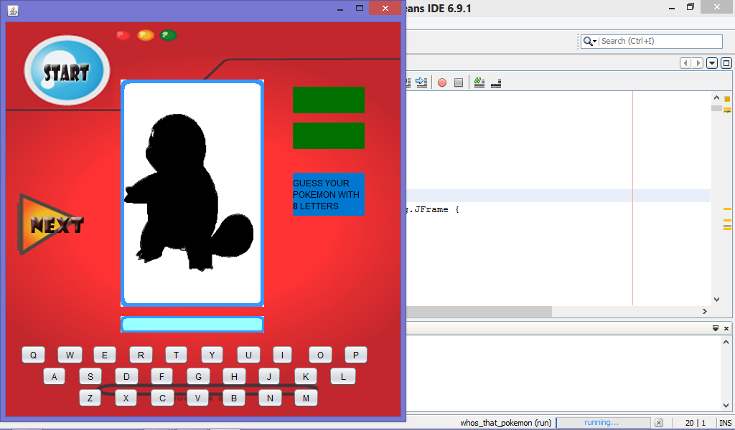

Test Case 2

Test Objective: To check if the alphabet buttons are working properly.

Expected Result: By pressing the alphabet buttons text will appear in the textbox.

Result:

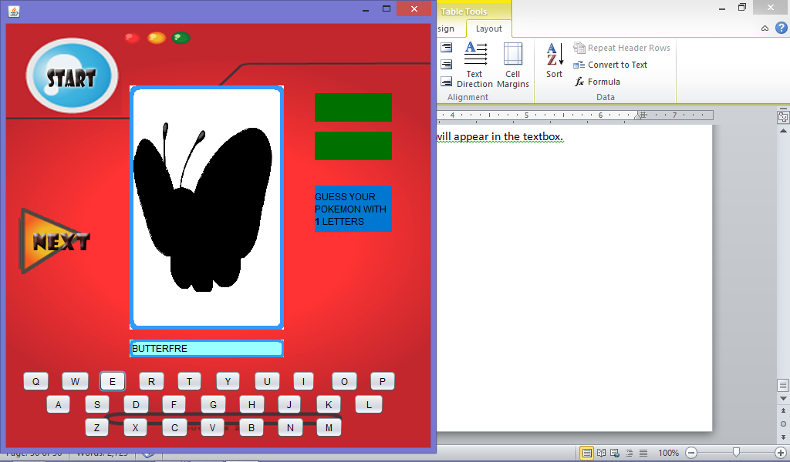

Test Case 3

Test Objective: To check if the Next Button will proceed to another image randomly.

Expected Result: By pressing the Next Button it will go to another image randomly + 1 to wrong.

Result:

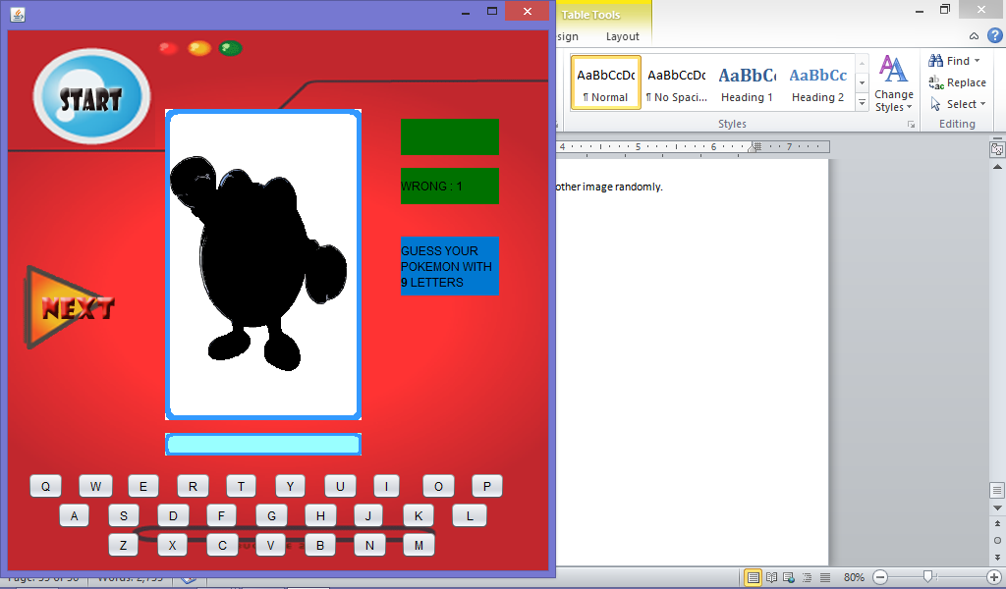

Test Case 4

Test Objective: To check if Start Button will restart the game.

Expected Result: By pressing the Start Button the game will restart the game erasing the correct and wrong scores.

Result:

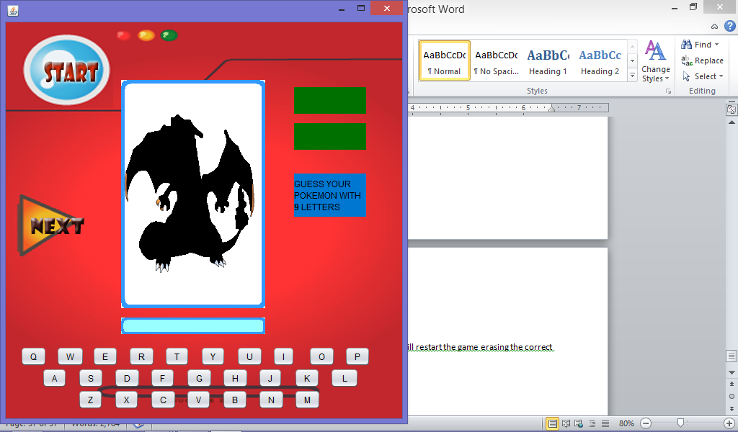

Test Case 5

Test Objective: To check if Pokémon is correct the image will appear.

Expected Result: Pokémon image will appear.

Result:

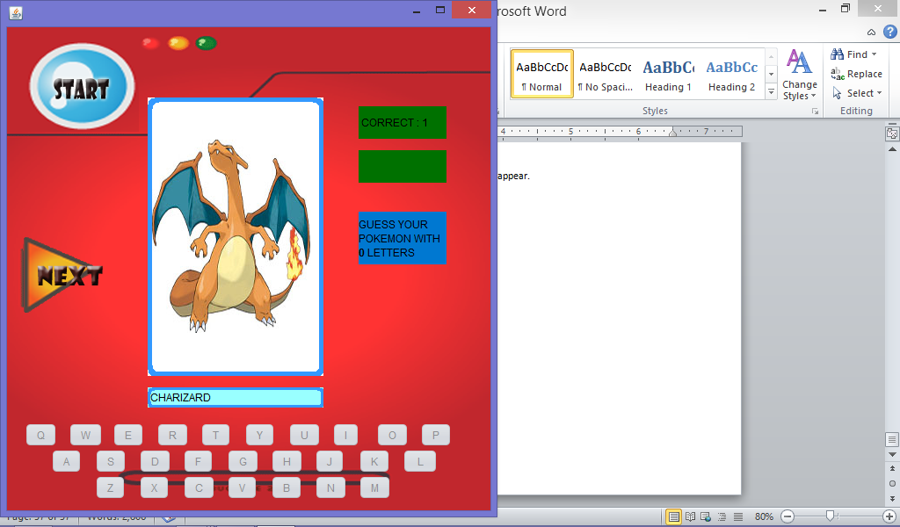

Test Plan

|  |  |
| --- | --- |
| Test Case | Test Results |
| 1 | Successful |
| 2 | Successful |
| 3 | Successful |
| 4 | Successful |
| 5 | Successful |

# Implementation

User Manual

We can start by opening the Netbeans icon in your desktop. Be patient, it will take some time to open all the modules.

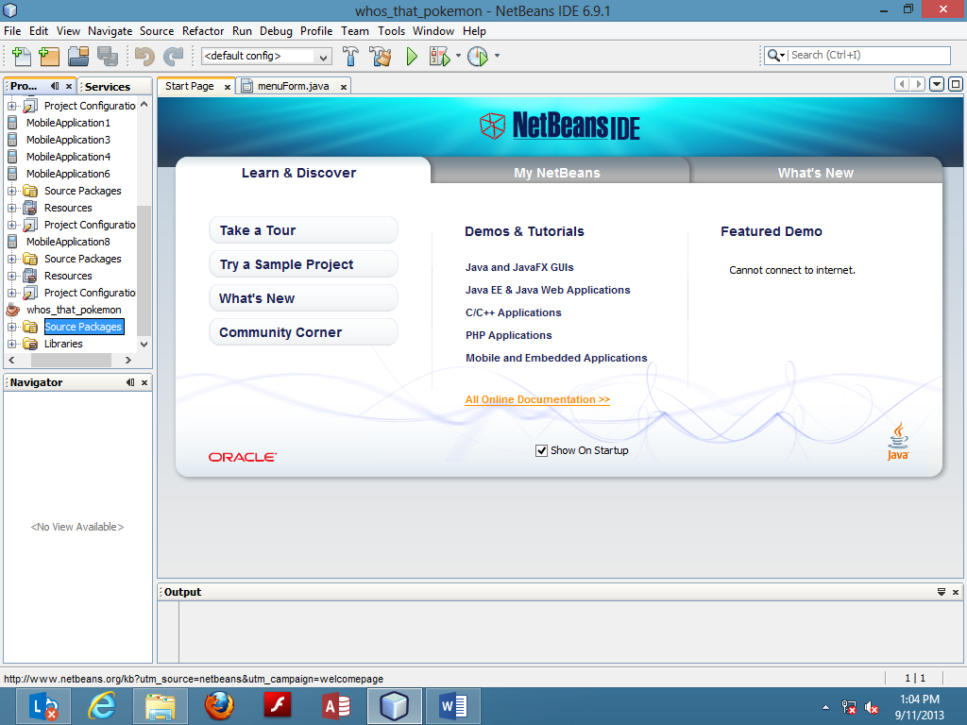

To open a project click **file >>> Open project**.

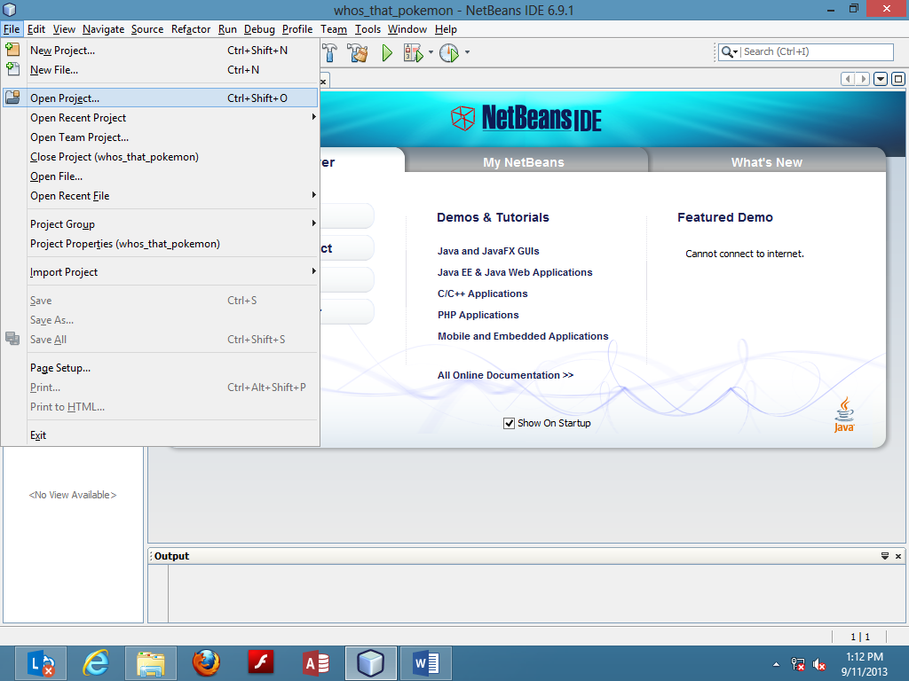

Choose your project then click **Open Project**.

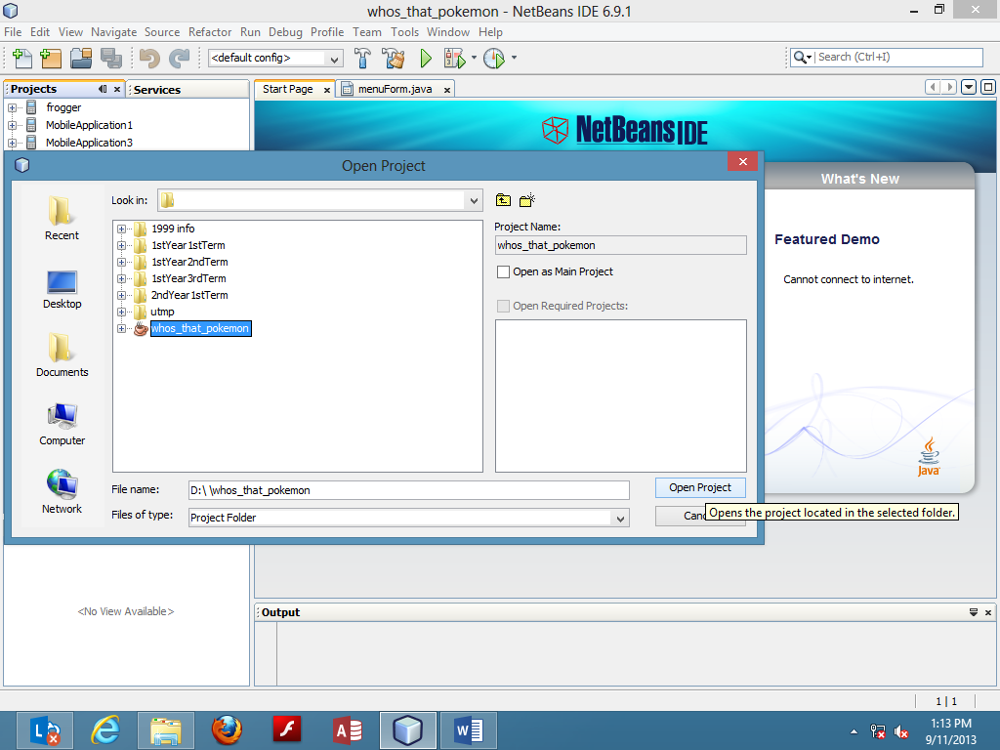

To open your project double click <project name> **>>> Source Pacakages >>>** <project name> **>>> MenuForm.java**. It will display on the right side of the screen.

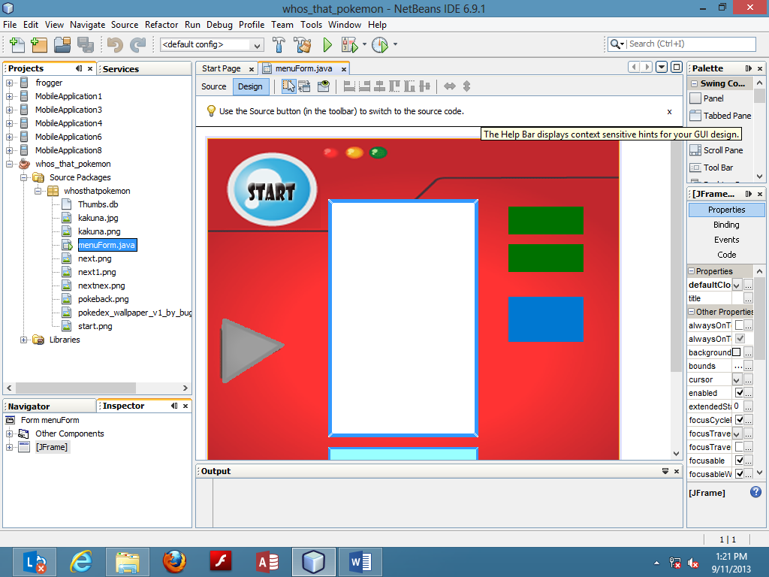

To run the program, click **Run >>> Run Project (project name)**.

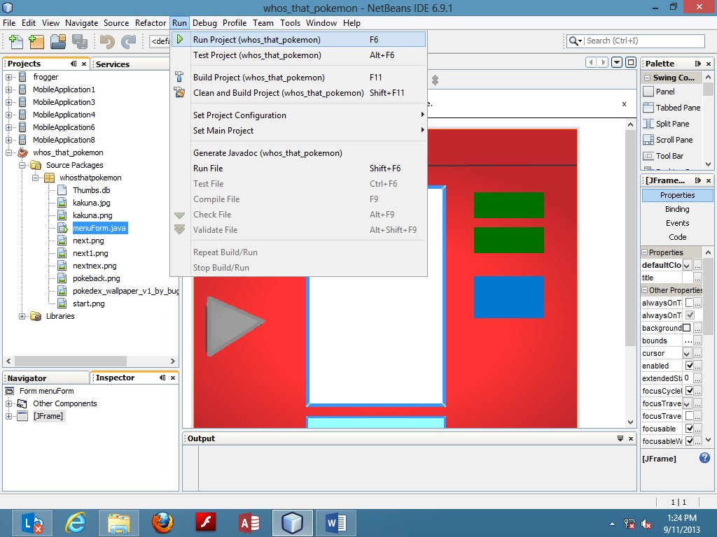

# Conclusion

## Strengths

The game is running smoothly. Shadowed Images will revealed itself once the user enters a correct Pokémon name.

## Weaknesses

Though this game is just a beta, it has no game over yet. It has no sounds, theirs only 36 Pokémon images. Once you enter a letter you cannot delete it anymore. Images will go in random so some Pokémon images will repeat itself as many times as it wants.

## Enhancements

This program needs more Pokémon images. It’s a game so it really needs a “game over”. Backspace button should place along with the games’ keyboard so if ever the user press a wrong key it will erase or deleted.